E-Commerce KPIs

- Total Number of Customers

- Total Number of Orders

- Total Revenue

- Average Order Value

- Total Number of Products

- Total Products Sold

- Most Expensive Product

- Least Expensive Product

- Number of Orders Per Customer

- Total Stock Quantity

- Products Out of Stock

- Total Orders in ‘2024-04-12’

- Most Recent Order

- Number of Orders by Month

- Find all products that cost less than $50

- Best Selling Product (by quantity)

- Find all products that are out of stock:

- Number of Orders by Day of Week

- Average Order Value by Custome
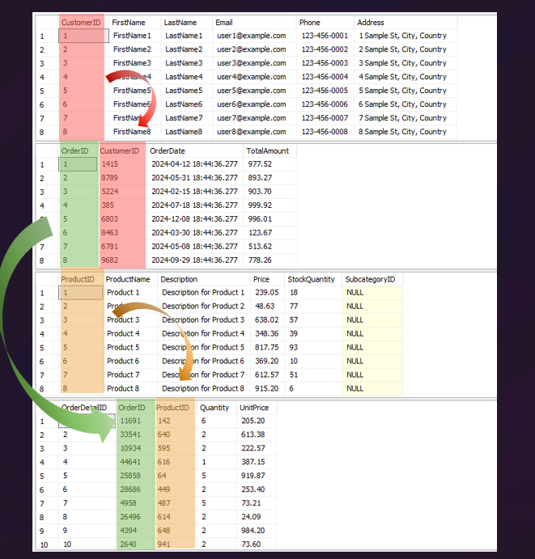
- Products with Price Above Averag

